# Python Worksheet

## Program 1

Using your Python IDE you should write a program which asks the user to enter their first name and surname. The program should then show the user a personalised greeting. Remember to structure your program in a procedure. The example that you worked through earlier in the lesson is shown below to help you.



## Program 2

Expand your program so that the user can enter their age. The personalised greeting should then also be expanded to include their age. For example, “Hello Gareth. It is nice to meet you. You are 9 years old”.

## Error Spotting

The program below contains three errors. Can you spot what they are?

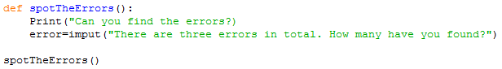

Once you have spotted the errors try entering the corrected program into your computer. Does it run?

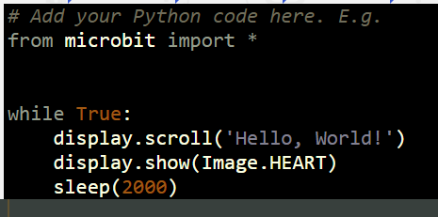

# Stretch Task

Try to use an IF statement to create a password entry system. Use the internet to help you. <https://www.w3schools.com/python/python_conditions.asp>